Software Requirements Specification (SRS) for Encrypted Chat Application Project

*Baseline version 0.1*

*Issued on : 07 August 2015*

Issued by : Jacky-Verrel-Chrys, Inc.

Issued for : Robertus Hudi

**Change History**

|  |  |  |  |
| --- | --- | --- | --- |
| **Version** | **Date** | **Author** | **Changes** |
| 0.1 | July 12, 2015 | Jacky | initial version |
| 0.2 | July 20, 2015 | Verrel | improvement |
| 0.3 | July 27, 2015 | Chrys | debugging |
| 0.4 | August 7. 2015 | Jacky,Verrel,Chrys | finalization |

**Document Approval**

The following Software Requirements Specification has been accepted and approved by the following :

|  |  |  |  |
| --- | --- | --- | --- |
| **Name** | **Title** | **Date** | **Signature** |
| Jacky Wira Kusuma | Member | 7 August 2015 | -sign- |
| Verrel Panahatan Nainggolan | Member | 7 August 2015 | -sign |
| Chrys Kelana Lim | Member | 7 August 2015 | -sign- |

**Table of Contents**

1. **Introduction ---------------------------------------------------------------------( 4 )**

**1.1. Purpose ---------------------------------------------------------------------( 4 )**

**1.2. Scope ------------------------------------------------------------------------( 4 )**

**1.3. Overview --------------------------------=---------------------------------( 4 )**

1. **General Description -----------------------------------------------------------( 5 )**

**2.1. Product Perspective ------------------------------------------------------( 5 )**

**2.2. Product Functions --------------------------------------------------------( 5 )**

**2.3. User Characteristics ------------------------------------------------------( 5 )**

**2.4. General Constraints ------------------------------------------------------( 5 )**

**2.5. Assumptions and Dependencies ----------------------------------------( 5 )**

1. **Specific Requirements ----------------------------------------------------------( 6 )**

**3.1. External Interface Requirements -------------------------------------( 6 )**

**3.2. Functional Requirements -----------------------------------------------( 6 )**

**3.3. Use cases ---------------------------------------------------------------------( 6 )**

**3.4. Classes/Objects --------------------------------------------------------------( 6 )**

**3.5. Non-Functional Requirements -------------------------------------------( 7 )**

**3.6. Design Constraints ---------------------------------------------------------( 7 )**

**3.7. Other Requirements -------------------------------------------------------( 7 )**

1. **Analysis Models ------------------------------------------------------------------( 8 )**

**4.1. Sequence Diagram ---------------------------------------------------------( 8 )**

**5. Change Management Process --------------------------------------------------( 9)**

**Chapter 1**

**INRODUCTION**

* 1. **Purpose**

The purpose of this project is to learn on how to create encrypted chat message during our university life. It is part of Keamanan Komputasi subject

The objectives of the project is to complete the subject curriculum and to learn how to improve chat security.

* 1. **Scope**

This product is called Encrypted Chat Application. It can help people to improve their security for chat messenger by implementing encryption. However, this product can only connect 2 people and not more.

There is no hardware in this product, only 5 text files which can be opened via Notepad++. It is a java-based codes.

* 1. **Overview**

Chapter 1 will only touch the introduction about our product, including the scope.

Chapter 2 is about general factors that will affect the product and the customer requirements, and also the ups and downs of it.

Chapter 3

Chapter 4 is a diagram about how the system works.

Chapter 5 talks about future plans (if we want to give updates or do any changes).

**Chapter 2**

**GENERAL DESCRIPTION**

1. **Product Perspective**

This product is individual, and thus does not need any helps to work. No hardware included since it is a program.

Client

Server

1. **Product Functions**

There are 5 .txt files in the programs which consist of the java codes. Customers will have to run these by using cmd. Firstly, run the mainServer.java which will require you to input IP address and port. Type the number in and after that, run the mainClient.java. 2 people will now be connected and can start chatting in a safe encrypted chat application.

1. **User Characteristics**

Users are required to have cmd to run this service and have java installed.

1. **General Constraints**

* Time
  + 2 weeks

- Etc

* + We have other projects for other subjects in that semester
  + Limited knowledge

1. **Assumptions and Dependencies**

If users change to new laptop or desktop which do not have java pre-installed, they will have to reinstall their java in order to use this application.

In future update, if we try to apply live-update to this application, users may need to have a faster internet connection.

**Chapter 3**

**SPECIFIC REQUIREMENTS**

1. **External Interface Requirements**

Users who own computer can use this program as long as they install java. There is no more additional requirements.

1. **Functional Requirements**

Users must input the IP address and port of the server to successfully run the program.

The text sent by user is encrypted and decrypted on receive.

User can see the message sent after encryption and message received before decryption.

1. **Use Cases**

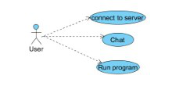

1. **Classes/Objects**

Server

Client

User

connect

run

-encrypt

-decrypt

-chat

-encrypt

-decrypt

-chat

-run the program

1. **Non-Functional Requirements**

Internet Connection

Electricity

Suitable Devices

1. **Design Constraints**

We do not know much about this subject since we have not been taught about it at all. As a result, the coding part was a challenge for us. Furthermore, due to limited time and resources, the design of the chat application is not that outstanding.

1. **Other Requirements**

User have basic knowledge about computer networking.

**Chapter 4**

**ANALYSIS MODELS**

*List all analysis models used in developing specific requirements previously given in this SRS. Each model should include an introduction and a narrative description. Furthermore, each model should be traceable the SRS’s requirements.*

1. **Sequence Diagrams**

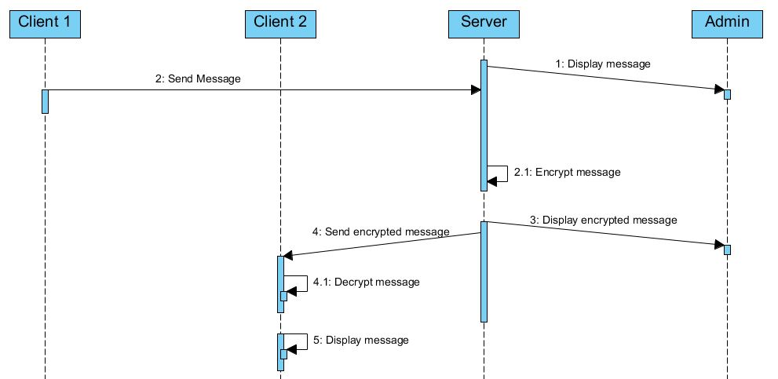

**Chapter 5**

**CHANGE MANAGEMENT PROCESS**

Suggestions and requests will be reported to everyone vocally or through email, since we are a small group this is the easiest way. When a suggestion/request has been made the decision to implement the change will be decided through discussion and voting, each member has an equal amount of power to raise their voice to vote and if the majority agrees then the change will be commenced, but if the majority disagrees the change will be thrown out.